Gandhi Jayanthi

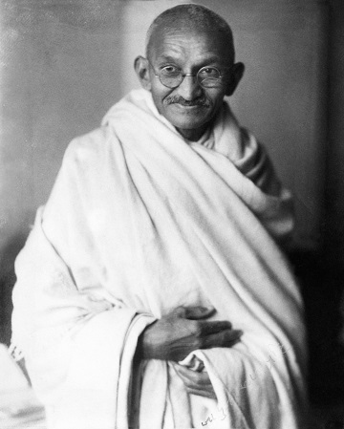

M

ohandas Karamchand Gandhi[c] (2 October 1869 –30 January 1948)[2] was an Indian lawyer, anti-colonial nationalist, and political ethicist who employed nonviolent resistance to lead the successful campaign for India's independence from British rule. He inspired movements for civil rights and freedom across the world. The honorific Mahatma (from Sanskrit, meaning great-souled, or venerable), first applied to him in South Africa in 1914, is now used throughout the world

Born and raised in a Hindu family in coastal Gujarat, Gandhi trained in the law at the Inner Temple in London and was called to the bar at the age of 22. After two uncertain years in India, where he was unable to start a successful law practice, Gandhi moved to South Africa in 1893 to represent an Indian merchant in a lawsuit. He went on to live in South Africa for 21 years. Here, Gandhi raised a family and first employed nonviolent resistance in a campaign for civil rights. In 1915, aged 45, he returned to India and soon set about organising peasants, farmers, and urban labourers to protest against discrimination and excessive land tax.

Assuming leadership of the Indian National Congress in 1921, Gandhi led nationwide campaigns for easing poverty, expanding women's rights, building religious and ethnic amity, ending untouchability, and, above all, achieving swaraj or self-rule. Gandhi adopted the short dhoti woven with hand-spun yarn as a mark

of identification with India's rural poor. He began to live in a self-sufficient residential community, to eat simple food, and undertake long fasts as a means of both introspection and political protest. Bringing anti-colonial nationalism to the common Indians, Gandhi led them in challenging the British-imposed salt tax with the 400 km (250 mi) Dandi Salt Assuming leadership of the Indian National Congress in 1921,

Computer basics

An **analog computer** or **analogue computer** is a type of [computation](https://en.wikipedia.org/wiki/Computation) machine (computer) that uses physical phenomena such as [electrical](https://en.wikipedia.org/wiki/Electrical_network), [mechanical](https://en.wikipedia.org/wiki/Mechanics), or [hydraulic](https://en.wikipedia.org/wiki/Hydraulics) quantities behaving according to the mathematical principles in question (*[analog signals](https://en.wikipedia.org/wiki/Analog_signal" \o "Analog signal)*) to [model](https://en.wikipedia.org/wiki/Scientific_modelling) the problem being solved. In contrast, [digital computers](https://en.wikipedia.org/wiki/Digital_computer) represent varying quantities symbolically and by discrete values of both time and amplitude ([digital signals](https://en.wikipedia.org/wiki/Digital_signal)).

Analog computers can have a very wide range of complexity. [Slide rules](https://en.wikipedia.org/wiki/Slide_rule) and [nomograms](https://en.wikipedia.org/wiki/Nomogram" \o "Nomogram) are the simplest, while naval gunfire control computers and large hybrid digital/analog computers were among the most complicated.[[1]](https://en.wikipedia.org/wiki/Analog_computer#cite_note-9HtsB-1) Complex mechanisms for [process control](https://en.wikipedia.org/wiki/Process_control) and [protective relays](https://en.wikipedia.org/wiki/Protective_relay) used analog computation to perform control and protective functions.

Analog computers were widely used in scientific and industrial applications even after the advent of digital computers, because at the time they were typically much faster, but they started to become obsolete as early as the 1950s and 1960s, although they remained in use in some specific applications, such as aircraft [flight simulators](https://en.wikipedia.org/wiki/Flight_simulator), the [flight computer](https://en.wikipedia.org/wiki/Flight_computer) in [aircraft](https://en.wikipedia.org/wiki/Aircraft), and for teaching [control systems](https://en.wikipedia.org/wiki/Control_system) in universities. Perhaps the most relatable example of analog computers are [mechanical watches](https://en.wikipedia.org/wiki/Mechanical_watch) where the continuous and periodic rotation of interlinked gears drives the second, minute and hour needles in the clock. More complex applications, such as aircraft flight simulators and [synthetic-aperture radar](https://en.wikipedia.org/wiki/Synthetic-aperture_radar), remained the domain of analog computing (and [hybrid computing](https://en.wikipedia.org/wiki/Hybrid_computer)) well into the 1980s, since digital computers were insufficient for the task.[[2]](https://en.wikipedia.org/wiki/Analog_computer#cite_note-Johnston-2)